GUARD INTERNAL
FOR GUARD OFFICERS, MYSTIGUARD, AND MYSTIGUARD-RELATED GUARD ACADEMY PERSONNEL ONLY
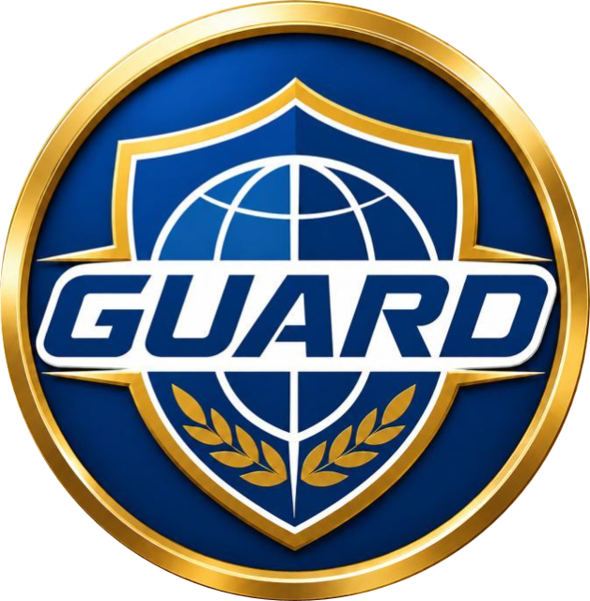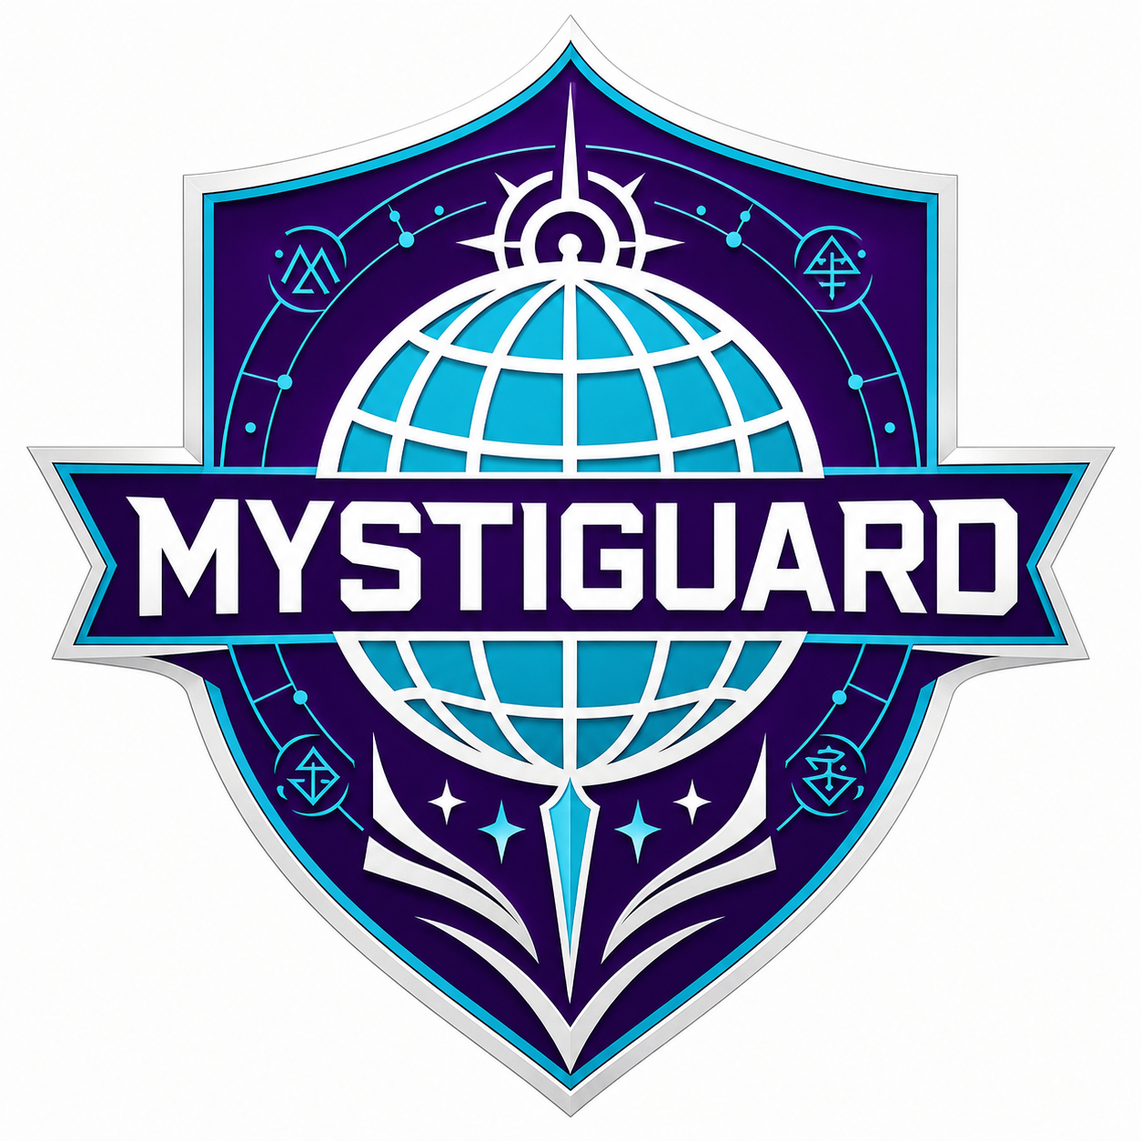
GUARD MYSTIGUARD ORIENTATION AND DOCTRINE HANDBOOK
Magic, Mystical Threats, and GUARD Response Doctrine
MYSTIGUARD
GUARD Mystical Operations Division
Motto: Between the Hidden and the World.

Version 1.0
Issued under GUARD Global Operations Command
Prepared for internal orientation, doctrine familiarization, and authorized training use.

Distribution and Use Notice
This handbook is an internal GUARD orientation and doctrine document intended only for GUARD Officers, MYSTIGUARD personnel, and MYSTIGUARD-related GUARD Academy personnel. It is not a public-facing publication.
This edition excludes classified floor-by-floor layout details for Sanctum Aegis, Black Vault engineering specifications, portal schematics, live artifact registry data, active access-control procedures, and compartmented operational annexes.
Personnel encountering subjects, artifacts, beings, sites, or incidents beyond the scope of this handbook must elevate the matter through proper MYSTIGUARD command channels and applicable review boards.
Handle, store, transmit, and discuss this handbook only within authorized GUARD systems and approved professional settings.

Table of Contents
- Foreword
- Commander's Note
- How to Use This Handbook
- Section I. Foundations of Magic in the MDU
- Section II. Schools of Magic
- Section III. Magical Orders, Hidden Authorities, and Governance
- Section IV. Magical Geography, Sites, and Ley-Line Systems
- Section V. Magical Beings, Species, and Nonhuman Societies
- Section VI. Magical Artifacts, Relics, and Containment Doctrine
- Section VII. Magical Threats, Incident Types, and Response Protocols
- Section VIII. MYSTIGUARD Division Design Requirements
- Section IX. MYSTIGUARD Initial Organizational Structure
- Section X. MYSTIGUARD Division Profile
- Section XI. Leadership Framework and Key Roles
- Appendix A. Glossary and Acronym List
- Appendix B. Schools of Magic Quick Reference
- Appendix C. MYS Incident Severity Scale
- Appendix D. MCL Artifact Containment Scale
- Appendix E. Strategic Site and Ley-Line Reference
- Appendix F. Magical Beings Classification Reference
- Appendix G. Cross-Division Coordination Matrix
- Appendix H. MYSTIGUARD Organizational Quick Reference

Foreword
Welcome to MYSTIGUARD.
If you are reading this handbook, you have either been assigned to support mystical operations, selected for training relevant to magical incident response, or entrusted with command, policy, investigative, intelligence, medical, legal, or field responsibilities that intersect with Earth’s hidden magical realities.
Magic is real. It is not metaphor, folklore, or a decorative layer on top of ordinary crisis response. It is an operational domain with its own dangers, traditions, politics, ethical obligations, and strategic consequences.
This handbook exists because the worst time to learn that distinction is during a live artifact breach, a Charm-compromised testimony chain, a ley-line disruption, or a magical beings rights incident handled by personnel who mean well but do not yet understand what they are seeing.
MYSTIGUARD was built to ensure that GUARD addresses mystical threats with discipline instead of superstition, with doctrine instead of improvisation, and with accountability instead of secrecy for secrecy’s sake. Study this handbook accordingly.
— Dr. Helena Maris Vey, “Threshold”
Commander, MYSTIGUARD

Commander’s Note
MYSTIGUARD stands between two failures. The first is ignorance: treating magic as rumor until it kills people. The second is surrender: treating magic as something too ancient, too beautiful, or too frightening to question.
Neither failure is acceptable.
Our task is to protect the world from magical threats while also protecting the magical world, where appropriate, from fear, exploitation, and reckless force. That means we study carefully, act professionally, document thoroughly, and remember that some of the people we protect will not be human, while some of the threats we face will look perfectly human.
Read this handbook as a starting point, not an ending point. It will orient you. It will not replace judgment, humility, lawful command, or the need to call for help early.
Know the doctrine. Respect the dangers. Protect the living. Hold the line between the hidden and the world.
— Threshold

How to Use This Handbook
This handbook is designed as an internal GUARD orientation and doctrine guide. It should be read in order on first issue, then retained as a reference document.
- Sections I–IV establish the foundational understanding of magic, schools, governance, sites, and ley-line systems.
- Sections V–VII explain what GUARD personnel may encounter operationally: magical beings, artifacts, incidents, and response doctrine.
- Sections VIII–XI define MYSTIGUARD itself: why the division exists, how it is structured, and who its key leaders are.
- Appendices provide quick-reference material for field orientation, training, and command review.
- Detailed Sanctum Aegis layout information is intentionally omitted from this edition for security reasons.

Section I. Foundations of Magic in the MDU
For GUARD purposes, magic is defined as a real energy phenomenon of varying frequencies that permeates life-bearing worlds and can be accessed, shaped, transmitted, stored, or weaponized under certain conditions.
Current MDU canon treats magic as arising from a blend of planetary magnetic fields, quantum forces, planetary core heat, and solar/cosmic exposure. Earth is unusually rich in magical saturation and purity, making it both strategically valuable and unusually vulnerable.

Core Principles
- Magic is not imaginary; it is an operationally real force.
- Magic varies by frequency, discipline, and method of access.
- Earth contains naturally strong magical saturation relative to many worlds.
- Ley lines act as major conduits for magical flow and concentration.
- Living beings, the dead, artifacts, and sites may all function as magical reservoirs or conductors.
- Training traditions formed around frequencies and methods eventually became known as schools of magic.

Operational Implications for GUARD
- Magical events can resemble disasters, crimes, epidemics, hauntings, terrorist incidents, or anomalous technology failures.
- Normal evidence, testimony, and chain of command can be corrupted by magical influence.
- Magic must be handled as a standing security domain, not as an occasional curiosity.
- MYSTIGUARD exists because no standard GUARD command can own the whole magical problem set alone.

Section II. Schools of Magic
Schools of magic are organized traditions of study and practice built around identifiable magical frequencies, methods, institutions, symbols, and cultures. Not every practitioner is school-trained, but the school model remains the most useful framework for classification.

Current Working School List
School | Status | Primary Practices
Alteration | Active | Body alteration, transmutation, enchanting, mystical storage
Arcane | Active | Projection, control, magical defenses, portals
Charm | Active | Illusion, psionic overlap, manipulation, domination
Conjuration | Active | Artifact creation, summoning, teleportation, banishment
(Death) | Defunct / suppressed | Dark arts, curses, affliction, necromancy, vampirism
(Dimensional) | Defunct | Gateways, life control, summoning, molecular conversion
Divination | Active | Scrying, post-cognition, precognition, magical detection
Druidic | Active | Shape-shifting, plant control, animal control, weather
(Holy) | Defunct / lost | Blessings, exorcisms, healing
Nature | Active | Elemental force and elemental control
Spirit | Active | Spirit communication, astral projection, spirit movement, spirit combat
Technomagic | Active / rapidly growing | Magical engineering, invention, cybernetics, energy conversion

Important Interpretive Notes
- The parenthesized schools in older materials (Death, Dimensional, Holy) remain important even if they are defunct, suppressed, or lost.
- Schools are cultural and political actors, not merely academic categories.
- School leaders, academies, and representative stones matter in identity disputes, historical custody claims, and symbolic authority.
- MYSTIGUARD uses school classification as a tool, not as an automatic endorsement of school politics.

Section III. Magical Orders, Hidden Authorities, and Governance
Magic in the MDU is not governed solely by the schools. Hidden authorities, independent orders, cults, and secrecy structures shape magical affairs in ways GUARD cannot ignore.

The Conglomerate
The Conglomerate is the principal hidden magical governance body presently recognized in working canon. It is powerful, secretive, preservationist, politically motivated, and not automatically trustworthy.
- It uses school stones as symbols of authority, frequency, and custodianship.
- It may preserve knowledge from active, suppressed, or defunct schools.
- It often frames secrecy as protection; GUARD must verify whether secrecy actually protects the public or protects power.

Priority Orders and Authorities
- Arkaenus: extreme-priority hostile magical order and soul-hunting cult.
- The Conglomerate: major hidden governance actor and intelligence concern.
- Independent magical orders: to be classified by behavior, not secrecy alone.
- The Soltan Star Empire: alien power with potential magical-energy exploitation implications.

GUARD Governance Position
- GUARD respects magical traditions but does not submit to hidden magical law.
- MYSTIGUARD operates under GUARD authority, not Conglomerate authority.
- Greenwich is foundational to MYSTIGUARD but cannot be unchecked.
- Legal, medical, intelligence, ethics, and PSIGUARD safeguards are part of MYSTIGUARD by design.

Section IV. Magical Geography, Sites, and Ley-Line Systems
Magical geography is strategic geography. Ley lines, sites, ruins, academies, vaults, and hidden societies create a map of magical infrastructure that can affect regional and global security.

Ley Lines
Ley lines are conduits of magical flow. High-density intersections create strategic nodes that can empower spells, support hidden sites, destabilize reality, or attract hostile operations.
- The Prime Meridian / Greenwich Ley-Line System is one of Earth’s strongest known magical conduits.
- Site access, artifact behavior, and portal instability may all be influenced by ley-line conditions.
- Monitoring ley-line conditions is a core MYSTIGUARD mission.

Current Core Site Baseline
Site | Classification | Reason
Antilla Isle | Protected / diplomatic interest | Hidden magical society and avian-linked concerns
Arkaenus Prime Temple | Red/Black-level | Hostile cult and artifact threat
Clanoch | Strategic / protected | Magical society with SEAGUARD relevance
Conglomerate Citadel | High secrecy concern | Governance, archives, hidden influence
Knights Arcanus Hacienda | Strategic | Order-linked site
Satanazes Isle | Sensitive / diplomatic | Demonic-associated populations requiring nuance
Pompeii Dimensional Site | Black-level if reactivated | Dimensional remnants
Black Church, Brasov | Red-level | Death magic / necromancy concern

Personnel should treat magical sites as combinations of heritage locations, weapons caches, diplomatic spaces, ecological systems, and potential disaster zones depending on context.

Section V. Magical Beings, Species, and Nonhuman Societies
Magical beings are not automatically monsters. For GUARD purposes they are classified by sentience, behavior, dependency, rights status, and threat posture rather than appearance alone.

Core Categories
- Sentient magical peoples and hidden societies
- Magical humanoids and transformed persons
- Avians and winged peoples
- Fairy-type beings
- Demonic / Satanazes / Seraphim-linked populations
- Spirit entities
- Cursed or transformed beings
- Magical animals
- Artifact-bound beings
- Dimensional beings
- Constructs and created beings

Foundational Rule
MYSTIGUARD classifies behavior before appearance, rights before threat, and dependency before containment.

Implications for Operations
- Sentient magical beings may be civilians, refugees, witnesses, allies, or sovereign actors.
- Some magical beings require ley-line proximity, magical atmosphere, sacred sites, or specific habitats to survive.
- Demonic association is not proof of hostile intent.
- Artifact-bound or transformed beings retain personhood questions that require legal and ethical review.
- Magical beings incidents frequently require Medical/Bio-Sciences, PSIGUARD, and World Court liaison participation.

Section VI. Magical Artifacts, Relics, and Containment Doctrine
Magical artifacts are among the clearest reasons MYSTIGUARD exists. An artifact is any object, structure, weapon, text, machine, tool, vessel, or material capable of storing, channeling, generating, altering, amplifying, concealing, corrupting, or transferring magical energy or effects.

Core Doctrine
No magical artifact is considered safe until it has been classified, contained, tested appropriately, cross-checked, and reviewed.

Origin and Status
- Artifacts may originate from schools, orders, the Conglomerate, hostile cults, Holy or Death traditions, Technomagic development, natural magical formation, alien-magical systems, or bound-being vessels.
- Status categories include dormant, active, reactive, bound, corrupted, sentient, unstable, strategic, and catastrophic.

Paragon Artifact Dispersal Event
Professor Paragon’s stolen artifact collection and the subsequent recovery campaign by Greenwich form one of MYSTIGUARD’s foundational case structures. The event demonstrated that heroic relics can become global risks if not institutionally tracked and contained.

Containment Principles
- MCL ratings govern vaulting and access.
- MCL-4 and above require multi-party authorization.
- MCL-6 artifacts require Director-level review and legal / World Court oversight.
- Sentient or artifact-bound beings are not automatically property.
- Technomagic devices must never be casually connected to GUARD systems.

Section VII. Magical Threats, Incident Types, and Response Protocols
MYSTIGUARD responds to magical incidents by identifying the threat type, school influence, public exposure, and required support structure before escalating the response.

Primary Incident Types
- Rogue mage incidents
- Hostile magical order activity
- Artifact incidents
- Curse and affliction events
- Summoning and Conjuration events
- Possession and spirit intrusion events
- Charm / domination events
- Ley-line disturbances
- Magical beings incidents
- Technomagic failures or attacks
- Death magic events
- Dimensional magical breaches
- Holy relic / exorcism events
- Hybrid and unknown events

Response Philosophy
- Identify before engaging.
- Contain before destroying.
- Verify school influence.
- Screen responders for contamination, manipulation, and compromise.
- Use joint response early rather than pretending MYSTIGUARD can solve everything alone.

Severity Model
MYS Level | Meaning
MYS-0 | Trace event
MYS-1 | Localized minor incident
MYS-2 | Controlled hazard
MYS-3 | Serious incident
MYS-4 | Major threat
MYS-5 | Strategic magical crisis
MYS-6 | Catastrophic magical event

Section VIII. MYSTIGUARD Division Design Requirements
MYSTIGUARD was designed as a professional GUARD division, not a mage club, artifact warehouse, occult police force, or Greenwich’s personal crusade.

Why MYSTIGUARD Exists
- No other GUARD command fully owns the magical problem set.
- Artifacts, ley lines, magical beings, curses, hostile orders, Death magic, and technomagic require integrated doctrine.
- GUARD needed a division capable of combining response, containment, intelligence, diplomacy, ethics, and training.

Design Principles
- Accountable magical power
- Multi-discipline staffing
- No single magical authority
- Civilian protection and sentient rights
- Containment before exploitation
- Verification of hidden authorities
- Psychological and ethical safeguards
- Serious treatment of Technomagic

Section IX. MYSTIGUARD Initial Organizational Structure
MYSTIGUARD operates under GUARD Global Operations Command with a split-location structure composed of a GUARD HQ Liaison Suite and Sanctum Aegis as its main operational facility.

Core Branches
- Command & Doctrine Branch
- Mystical Operations Branch
- Artifact & Containment Branch
- Intelligence & Analysis Branch
- Research, Forensics & Technomagic Branch
- Liaison & Strategic Sites Branch

Sanctum Aegis (Non-Classified Summary)
Sanctum Aegis is the primary MYSTIGUARD facility beneath Langone Park extending toward the waterfront, linked to GUARD HQ by a secure tunnel and restricted portal capability. This handbook does not reproduce its detailed internal layout.

Organizational Logic
The structure separates command, operations, containment, intelligence, technical analysis, and diplomacy so that no one personality, school, or pressure group can dominate the division.

Section X. MYSTIGUARD Division Profile
MYSTIGUARD is GUARD’s dedicated Mystical Operations Division under Global Operations Command. Its mission is to manage magical threats, artifacts, ley lines, magical beings, hidden magical orders, and technomagic hazards in defense of civilian life, sentient rights, and global stability.

Public and Internal Identity
Publicly, MYSTIGUARD is described as a specialized division for anomalous energy events, artifact-related hazards, culturally sensitive crisis operations, and extraordinary threat response. Internally, GUARD recognizes that MYSTIGUARD handles magic.

Division Motto
Between the Hidden and the World.

Founding Dynamic
The division was shaped in part by Greenwich’s expertise, history with Arkaenus, and connection to Professor Paragon’s artifact legacy; however, MYSTIGUARD is intentionally structured to be larger than any one advisor.

Section XI. Leadership Framework and Key Roles
The following leadership list is the current baseline for MYSTIGUARD. These roles exist to define authority, accountability, and functional ownership. Detailed character development may evolve over time, but the positions below are now established for handbook use.
Role | Assigned Leader | Basic Role Definition
Commander, MYSTIGUARD | Dr. Helena Maris Vey (“Threshold”) | Overall division command; sets operational priorities, approves major responses, and ensures MYSTIGUARD remains disciplined, lawful, and integrated with GUARD command.
Deputy Commander / Executive Officer | Commander Elias Northam | Manages day-to-day operations, readiness, staff coordination, and synchronization between Sanctum Aegis and GUARD HQ.
Founding Senior Magical Advisor | Leila Smith / Gwendalin Windsor (“Greenwich”) | Senior magical advisor; Arcane operations specialist; Paragon Artifact Recovery Lead; provides foundational magical expertise without unilateral command.
Chief of Artifact Recovery & Containment | Dr. Matteo Kessler | Oversees artifact intake, classification, vaulting, chain of custody, and MCL governance.
Chief of Magical Intelligence & Threat Analysis | Director Sana Okoye | Leads analysis on Arkaenus, the Conglomerate, rogue practitioners, magical trafficking, and hidden magical networks.
Chief of Mystical Operations | Colonel Adrian Rourke | Commands field-response doctrine, containment deployments, and tactical magical incident operations.
Chief of Ley-Line & Strategic Site Monitoring | Dr. Priya Elowen Basu | Directs magical site intelligence, ley-line monitoring, and strategic geography assessment.
Chief of Magical Beings Liaison & Protection | Ambassador Naila Serrano | Handles magical beings rights, diplomacy, protection, asylum, and intersocietal liaison.
Chief of Technomagic Review & Containment | Engineer Tobias Vale | Leads policy and technical control over magical devices, implants, spell circuits, and magical AI concerns.
Chief of Magical Forensics & Evidence | Dr. Mireille Dastan | Runs magical crime scene analysis, residue interpretation, and court-safe evidence procedures.
Chief of Policy, Ethics & Training | Professor Jonah Halberg | Owns doctrine, certification, responder standards, legal-ethical integration, and training architecture.
Sanctum Aegis Facility Director | Commander Lucía Fen | Responsible for site administration, internal security coordination, continuity of operations, and non-classified facility governance.
Black Vault Director | Director Oren Kaid | Controls catastrophic artifact custody procedures, emergency isolation doctrine, and high-level access coordination under applicable oversight.

Appendix A. Glossary and Acronym List
Term / Acronym | Definition
Arkaenus | Extreme-priority hostile magical order and soul-hunting cult.
Artifact | Any object or medium capable of storing, generating, channeling, or altering magical effects.
Black Vault | Catastrophic containment function for the highest-risk magical artifacts.
Charm | School and effect category involving illusion, manipulation, domination, or altered consent.
Conglomerate | Hidden magical governance body with significant historical influence and secrecy practices.
Death Magic | Suppressed / defunct school domain involving necromancy, curses, affliction, and vampirism.
Dimensional | Defunct school domain involving gateways, molecular conversion, and inter-reality breach risk.
External Magical Liaison Council | Advisory-only forum for MYSTIGUARD engagement with schools, beings, and orders.
Greenwich | Leila Smith / Gwendalin Windsor, Founding Senior Magical Advisor to MYSTIGUARD.
Holy | Lost school domain associated with blessings, healing, and exorcism.
Ley Line | Conduit of magical energy running across or through geographic space.
MCL | Magical Containment Level — the artifact custody and storage severity scale.
MYS | Magical incident severity scale used by MYSTIGUARD.
MYSTIGUARD | GUARD Mystical Operations Division.
Paragon Artifact Dispersal Event | Foundational MYSTIGUARD case concerning Professor Paragon’s stolen artifacts.
PE | Public Exposure level for magical incidents.
PORTALGUARD | GUARD command specializing in portal and dimensional boundary control.
PSIGUARD | GUARD command specializing in psychic, cognitive, and mental influence concerns.
Sanctum Aegis | MYSTIGUARD’s primary operational facility beneath Langone Park.
School | Institutional magical tradition organized around frequency, discipline, and training culture.
Technomagic | Magic integrated with machinery, cybernetics, systems, and engineered devices.
Threshold | Callsign of Dr. Helena Maris Vey, Commander of MYSTIGUARD.

Appendix B. Schools of Magic Quick Reference
School | Colors | Status | Academy Location | Core Notes
Alteration | Aquamarine/Teal | Active | Cairo, Egypt | Transmutation, body alteration, enchanting, storage
Arcane | Purple/White | Active | Greenwich, England | Projection, magical defenses, portals
Charm | Red/Pink | Active | Los Angeles, USA | Illusion, manipulation, domination
Conjuration | Yellow/Gold | Active | Ankara, Turkey | Summoning, banishment, teleportation
Death | Black/Grey/Red | Suppressed | No active academy | Necromancy, curses, vampirism
Dimensional | Light Green/Black | Defunct | No active academy | Gateways, molecular conversion
Divination | Dark Blue/Blue | Active | Monrovia, Liberia | Scrying, precognition, detection
Druidic | Green/Light Green | Active | Newgrange, Ireland | Nature-linked living systems and weather
Holy | White/Gold | Lost | No active academy | Healing, blessings, exorcism
Nature | Red/Blue | Active | New Zealand isles | Elemental force and control
Spirit | White/Light Gray | Active | Beijing, China | Spirit communication and astral activity
Technomagic | Yellow/Orange | Active / growing | Mexico City, Mexico | Magical engineering and magical technology

Appendix C. MYS Incident Severity Scale
Level | Meaning | Standard Response
MYS-0 | Trace Event | Document and monitor.
MYS-1 | Localized Minor Incident | Small MYSTIGUARD advisory or field assessment response.
MYS-2 | Controlled Hazard | Field team with specialist support.
MYS-3 | Serious Incident | Full MYSTIGUARD deployment and command notification.
MYS-4 | Major Threat | Joint magical incident task force.
MYS-5 | Strategic Magical Crisis | Global Operations Command oversight and executive notification.
MYS-6 | Catastrophic Magical Event | Director-level authority and full crisis posture.

Appendix D. MCL Artifact Containment Scale
Level | Meaning | Notes
MCL-0 | Archive safe | Residual or inert item.
MCL-1 | Low active | Minor active effect; basic warded storage.
MCL-2 | Restricted active | Trained handling required.
MCL-3 | Hazardous | Can harm, curse, conceal, or destabilize.
MCL-4 | Severe | Entity, summoning, or major site-level effect; multi-party authorization.
MCL-5 | Strategic | Regional, portal, or ley-line significance; command-level oversight.
MCL-6 | Catastrophic | Mass-casualty, soul-scale, or reality-level risk; Director-level oversight.

Appendix E. Strategic Site and Ley-Line Reference
The following is a quick-reference subset of the strategic magical geography baseline.
Site / System | Type | Operational Importance
Prime Meridian / Greenwich Ley-Line System | Ley-line nexus | One of Earth’s strongest magical conduits.
Sanctum Aegis | GUARD facility | Primary MYSTIGUARD facility; operational and containment center.
Antilla Isle | Magical society site | Diplomatic and species-liaison importance.
Clanoch | Magical society site | SEAGUARD and MYSTIGUARD crossover relevance.
Satanazes Isle | Sensitive magical population zone | Requires nuanced rights and threat handling.
Arkaenus Prime Temple | Hostile cult site | Extreme-priority threat site.
Conglomerate Citadel | Hidden authority site | Secrecy and political intelligence significance.
Pompeii Dimensional Site | Defunct-school remnant | Black-level reactivation risk.
Black Church, Brasov | Death-magic site | Red-level Death magic concern.

Appendix F. Magical Beings Classification Reference
Category | Examples / Notes | Primary Concern
Sentient Magical Peoples | Hidden societies, sovereign groups | Rights, diplomacy, security
Magical Humanoids | Human-adjacent or lineage-linked persons | Protection, registration, threat review
Avians | Winged peoples and related lineages | Airspace, medical, diplomatic handling
Fairy-Type Beings | Fae-linked groups and contract cultures | Bargain risk, territory, illusion
Demonic / Satanazes-Linked | Hostile or civilian demonic-linked populations | Do not assume guilt by lineage
Spirit Entities | Ghosts, trapped souls, astral intelligences | Communication, rescue, containment
Cursed / Transformed Beings | Victims or altered persons | Medical, legal, consent review
Magical Animals | Endangered, altered, or summoned creatures | Ecology and public safety
Artifact-Bound Beings | Trapped or sustained by items | Sentience and ownership ethics
Dimensional Beings | Visitors, refugees, predators, intruders | Containment, return, diplomacy
Constructs | Created or technomagic beings | Sentience and control review

Appendix G. Cross-Division Coordination Matrix
Incident Type | Primary Partner | Additional Support
Charm / Possession / Spirit intrusion | PSIGUARD | Medical, Legal, MYSTIGUARD
Dimensional breach | PORTALGUARD + MYSTIGUARD | ASTROGUARD, Global Ops, Medical
Alien-magical overlap | ASTROGUARD + MYSTIGUARD | Intelligence, PORTALGUARD as needed
Artifact security compromise | MYSTIGUARD + SSIIC | Legal, Intelligence, XGUARD if escalated
Technomagic system incident | MYSTIGUARD + Cybersecurity/Signals | Engineering, Medical, SSIIC
Magical beings rights / asylum case | MYSTIGUARD | Medical, Legal, World Court liaison
Ley-line environmental event | MYSTIGUARD | TERRAGUARD / AEROGUARD / SEAGUARD / PORTALGUARD
Hostile magical order operation | MYSTIGUARD + Intelligence | SSIIC/XGUARD, PSIGUARD

Appendix H. MYSTIGUARD Organizational Quick Reference
Quick reference for the current organizational baseline:
- Parent Command: GUARD Global Operations Command
- Primary Facility: Sanctum Aegis
- HQ Interface: MYSTIGUARD Liaison Suite at GUARD HQ
- Motto: Between the Hidden and the World.
- Commander: Dr. Helena Maris Vey (“Threshold”)
- Founding Senior Magical Advisor: Greenwich
- Core Branches: Command & Doctrine; Mystical Operations; Artifact & Containment; Intelligence & Analysis; Research, Forensics & Technomagic; Liaison & Strategic Sites
- Standing Review Boards: Artifact Disposition; Magical Beings Rights; Arkaenus Conflict; Technomagic Safety
- Advisory Body: External Magical Liaison Council (advisory only)

